Isotope Workshop XI, 4-8 July 2011, Budapest, Hungary
Isotope Workshop XI
4th-8th July, 2011
Budapest, Hungary
Programme
Organized by
the European Society for Isotope Research (ESIR)
&
the Institute for Geochemical Research,
Hungarian Academy of Sciences
Monday
8:00-10:00 | Registration
10:00-10:30 | Opening Ceremony
Inert Gas and Radiogenic Isotopes
Key-Note Lecture (Chairpersons: Hedvig Éva Nagy and György Czuppon)
10:30-11:00 | Hedvig Éva Nagy, Csaba Szabó, Ákos Horváth, Attila Kiss |  | Study of the behaviour of radon isotope in Pál-völgy show cave (Budapest, Hungary)
11:00-11:20 | Katalin Zsuzsanna Szabó, Ákos Horváth, Csaba Szabó |  | ²²²Rn concentration measurements of soil gas in Hungary
11:20-11:40 | Péter Völgyesi, Hedvig Éva Nagy, Csaba Szabó |  | Examination of radiogenic isotopes and chemical composition of coal slag and fly ash bearing building materials
11:40-12:00 | Zsuzsanna Szabó, Csaba Szabó, Ákos Horváth |  | Testing of fast ²²²Rn and ²²⁰Rn exhalation measurements of high number of Hungarian adobe building material samples
12:00-14:00 | Lunch
14:00-14:20 | István Vető, László Palcsu, István Futó, Gergely Vodila, László Papp, Zoltán Major |  | Isotopic constraints on genesis of the multistacked CO₂-CH₄-N₂ Répcelak gas field (Pannonian Basin System, W Hungary)
14:20-14:40 | György Czuppon, Takuya Matsumoto, Jun-ichi Matsuda, Monica R. Handler, John Everard, Lin Sutherland |  | Noble gases in mantle derived xenoliths from Eastern Australia and their implications for the tectonic evolution: Summary
Technical Developments & General Isotope Geochemistry
Key-Note Lecture (Chairpersons: Stanisław Hałas and Ana-Voica Bojar)
14:40-15:10 | Stanisław Hałas |  | Innovations in technical developments of stable  isotope analyses
15:10-15:40 | Coffee Break
15:40-16:00 | Andrzej Pelc, Stanisław Hałas, Maciej Czarnacki |  | Chlorine stable isotope ratio analysis by the negative surface ionization of chloromethane
16:00-16:20 | László Palcsu, László Papp, Zoltán Major |  | Noble gas measurements from 1 μL of water: fluid inclusions of speleothems
16:20-16:40 | Wojciech Drzewicki, Stanisław Burliga, Janusz Krajniak, Łukasz Pleśniak, Mariusz-Orion Jędrysek |  | Dissolving halite for H, C and S isotopic analysis of fluid inclussions
16:40-18:00 | Poster Presentation
Inert Gas and Radiogenic Isotopes
Fausto Grassa, Giorgio Capasso, Paula M. Carreira, Maria R. Carvalho, Jose M. Marques, Manuel Antunes da Silva |  | Helium isotopes distribution in NW Iberian peninsula: evidences of a local neotectonic activity
Chau Dinh Nguyen, Jakub Nowak, Pawel Jodlowski |  | Uranium, radium and ²²²Rn isotopes in thermal waters from Podhale Trough (Polish Inner Carpathians)
Technical Developments
Maciej Czarnacki, Stanisław Hałas |  | Ab initio calculations of sulfur isotope fractionation factor for H₂S in aquagas system
Eric M. Galimov, V yacheslav S. Sevastyanov, Nataliya E. Babulevich, Alexander A. Arzhannikov |  | Rapid ²H analysis of small H₂O samples by CF-IRMS
Aleksandr V. Ignatiev, Tatiana A. Velivetskaya |  | UV laser ablation microanalysis of δ³⁴S
Ana Isabel Janeiro, Paula Galego Fernandes, Jorge M.R.S. Relvas, Miguel Gaspar, Fernando J.A.S. Barriga, Maria Conceição Freitas |  | The new Stable Isotope Laboratory at the University of Lisbon: a multi-isotopic facility oriented to earth and environmental sciences
Eric Wapelhorst, Hans-Jürg Jost, James J. Scherer, Joshua B. Paul |  | Simultaneous measurements of carbon and oxygen isotopologues of carbon dioxide using a mid-IR laser based platform
General Isotope Geochemistry
Izabella Havancsák, József Fekete, Bernadett Bajnóczi |  | Carbon isotope study on Celtic graphite-tempered archaeological ceramics from the South Transdanubian region (Hungary)
Michał Bucha, Łukasz Pleśniak, Katarzyna Kubiak, Mieczysław Blaszczyk, Mariusz-Orion Jędrysek |  | δ²H and δ¹³C of methane in lignite fermentation
Maciej Czarnacki, Stanisław Hałas, Andrzej Pelc |  | Calculation of chlorine and bromine isotope fractionation factors in aquagas system
Vasyl’ Guliy, Vasyl’ Zagnitko, Ruslana Bochevar |  | Origin of Precambrian carbonate rocks of the Ukrainian Shield by geological-structural peculiarities and isotopic signatures
Aleksandr V. Ignatiev, Viktor I. Levitskiy, Sergey V. Vysotskiy, Sergey Yu. Budnitskiy, Tatiana A. Velivetskaya |  | Anomalous δ¹⁸O isotope composition of minerals from North Karelia (Russia)
18:00-21:00 | Ice Breaker Party
Tuesday
Paleoclimate
Invited Lecture (Chairpersons: Markus Leuenberger and Nada Horvatinčić)
9:00-9:45 | Markus Leuenberger, Philippe Kindler, Christof Huber |  | Semi-continuous online isotope and elemental ratio measurements of high time resolution on Greenland ice cores for temperature reconstruction
9:45-10:05 | Rein Vaikmäe |  | Recent Achievements and future prospects of ice core science
10:05-10:25 | Aurel Perşoiu (presented by Ana-Voica Bojar) |  | Modelling the effects of melting and refreezing on the original isotopic signal in cave ice
10:25-10:55 | Coffee Break
10:55-11:15 | Julie Dabkowski, Nicole Limondin-Lozouet, Pierre Antoine, Alina Marca-Bell, Julian Andrews, Paul Dennis |  | Calcite carbon and oxygen stable isotopes in riverine tufas as paleoclimatic records of Interglacials: the sequence of Condat-sur-Vézère (MIS 5, South-western France)
11:15-11:45 | Liina Laumets, Volli Kalm |  | Stable O-isotope record of Holocene freshwater tufa in Lake Valgejärve, Estonia – an interpretation of postglacial climate changes
11:45-12:05 | Tõnu Martma, Dimitri Kaljo |  | Carbon and oxygen isotopes in Baltic Early Palaeozoic geology: some results and trends
12:05-14:00 | Lunch
Isotope Hydrology
Key-Note Lecture (Chairpersons: Kazimierz Różański and Paula Mimo Carreira)
14:00-14:30 | Kazimierz Różański, Marek Duliński, Krzysztof Bukowski |  | Badenian salinity crisis in Carpathian foredeep: new insights from stable isotope composition of fluid inclusions in halite deposits of Wieliczka and Bochnia, southern Poland
14:30-14:50 | Adam Porowski, Jan Dowgiałło, Stanisław Hałas, Roman Becker |  | Isotopic composition of sulphates dissolved in waters of deep aquifers associated with copper ore deposits: implications for sulphate source and water-rock interaction
14:50-15:10 | Gerhard Strauch, Khalid Al-Mashaikhi, Kay Knöller |  | Sulphate Reduction in Deep Groundwater
15:10-15:30 | Marek Duliński, Lucyna Rajchel, Jacek Rajchel |  | Stable isotope composition of carbon dioxide and TDIC reservoir associated with mineral waters of the Polish Flysch Carpathians
15:30-15:50 | Jean-Denis Taupin, Carla Manciati, Teresa Muñoz, Nelson Arias, Oscar Larrea, Rafael Alulema, Christian Leduc |  | Preliminary geochemical and isotope results in a hydrogeologic complex volcanic system aquifer in Tumbaco – Cumbayá region (Ecuador)
15:50-16:20 | Coffee Break
16:20-17:30 | Poster Presentation
Paleoclimate
Gabriella Barta, Paul Koeniger, Erzsébet Horváth, Manfred Frechen, Bernadett Bajnóczi |  | Stable isotope studies of secondary carbonates of the Süttő loess-paleosoil sequence, Hungary
Zoltán Kern, István Fórizs, László Palcsu, Michael Behm, Helmut Hausmann, Rudolf Pavuza |  | Isotope hydrological and geophysical studies on the perennial cave ice deposit of Saarhalle (Mammuthöhle, Dachstein Mts, Austria)
Bogdan P. Onac, Tudor Támaş, Iuliana Vişan |  | Stable isotopes of rainfall and dripwater at Ursilor Cave (Romania): the path to reliable speleothems paleoclimate reconstructions
Tatiana A. Velivetskaya, Nikolay G. Smirnov, Sergey I. Kiyashko, Alexandr V. Ignatiev, Alexandr I. Ulitko |  | Pleistocene seasonal temperature reconstructions from δ¹⁸O of bison teeth, Ural Russia
Isotope Hydrology
Anna Baran |  | Isotopic study of nitrates and bicarbonates in mineral waters of the Southeast Poland
Tamara Hunjak, Diana Mance, Hans O. Lutz, Zvjezdana Roller-Lutz |  | δ¹⁸O spatial distribution of precipitation in Croatia
Tjaša Kanduč, Nataša Mori, David Kocmanan, Vekoslava Stibilj, Fausto Grassa |  | Hydrogeochemistry of Alpine springs from North Slovenia: insights from stable isotopes
Krisztina Kármán, Piotr Maloszewski, István Fórizs, József Deák, Csaba Szabó |  | Estimation of groundwater transit time by lumped parameter model using δ¹⁸O on Szentendre Island, Hungary
Boglárka Mercedesz Kis, Krisztina Kármán, Calin Baciu |  | Isotopic investigations on some mineral waters from Corund, Harghita County, Romania
Nada Miljević, Ana Pešić, Dušan Golobočanin, Zoran Gršić, Miroslava Unkašević, Ivana Tošić |  | Relationship between atmospheric circulation and stable isotope composition of Belgrade daily precipitation
Gabriella Schöll-Barna, Attila Demény, Tibor Cserny, István Fórizs, Pál Sümegi |  | Oxygen isotope variations in shallow lake water and bivalve shells: application of the isotope mass balance model
Carmen Varlam, Ioan Stefanescu, Amalia Soare, Ionut Faurescu |  | Tritium level in several European surface waters
Polona Vreča, Mihael Brenčić |  | Detailed isotopic mapping of the karstic Savica River, NW Slovenia
17:30-18:30 | ESIR Assembly
Wednesday
Paleoclimate
Invited Lecture (Chairpersons: Christophe Lécuyer and Sándor Kele)
9:00-9:45 | Christophe Lécuyer |  | The isotopic memory of fossils
9:45-10:05 | Hazel Reade, Graeme Barker, Tony Legge, Tamsin O’Connell, Rhiannon Stevens |  | Correlating δ¹⁸O values of Barbary sheep tooth enamel and environmental waters: Implications for North African Palaeoclimate Reconstructions
10:05-10:25 | Attila Demény, Gabriella Schöll-Barna, Pál Sümegi |  | Sedimentary changes vs. climate signals in bivalve shell and bulk rock compositions in a Late Pleistocene to Early Holocene fluvial section at Körösladány, SE-Hungary
10:25-10:55 | József Deák, Sándor Kele, István Fórizs, Attila Demény, Gyula Scheuer |  | Calculation of temperature and δ¹⁸O of depositing water by measured δ¹⁸O of recent travertines deposited from the Budapest thermal karst water
10:55-11:20 | Coffee Break
Isotope Hydrology
Key-Note Lecture (Chairpersons: Matthias Cuntz and István Fórizs)
11:20-11:50 | Matthias Cuntz, Vanessa E Haverd, David W Griffith, Claudia Keitel, Carol Tadros, John Twining |  | Determining Forest Turbulent Transport and Evapotranspiration Partition with the Help of a new Soil Water Isotope Model
11:50-12:10 | Paula Mimo Carreira, José Manuel Marques, Maria do Rosário Carvalho, Fausto Grassa, Giorgio Capasso, Dina Nunes, João Carlos Nunes |  | Stable isotope feature of groundwaters from Graciosa volcanic Island (Azores) – preliminary results
12:10-14:00 | Lunch
14:00-14:20 | Nada Horvatinčić, Jadranka Barešić, Ines Krajcar Bronić, Krisztina Kármán, István Fórizs, Bogomil Obelić |  | Study of the bank filtered groundwater system of the Sava River at Zagreb (Croatia) using isotope analyses
14:20-14:40 | Paula Galego Fernandes, Maria Rosário Carvalho, Catarina Silva |  | Assessing the impacts of anthropogenic activities on groundwater quality using nitrogen isotopes-Alter do Chão-Monforte (portugal)
14:40-15:00 | George I. Melikadze |  | Application of isotopes for assessment of pollution probability of drinking water resources in Georgia
15:00-15:20 | Dominika Lewicka-Szczebak, Mariusz-Orion Jędrysek |  | Quantitative assessment of lake water balance components: new calculation approach
15:20-15:50 | Coffee Break
15:50-16:00 | Boarding the buses
16:00-19:00 | City Sightseeing
Thursday
Biogeochemistry
Key-Note Lecture (Chairpersons: Jaleh Ghashghaie and Mariusz-Orion Jędrysek)
9:00-9:30 | Jaleh Ghashghaie, Camille Bathellier, Guillaume Tcherkez & Franz W. Badeck |  | Metabolic origin of δ¹³C in dark-respired CO₂: Comparison between leaves and roots
9:30-9:50 | Gábor Somlyai, András Kovács, Imre Guller, Zoltán Gyöngyi, Krisztina Krempels, Ildikó Somlyai, Mariann Szabó, Tamás Berkényi, Miklós Molnár |  | Deuterium depletion as a new approach in cancer treatment and prevention
9:50-10:10 | Ana Isabel Janeiro, Luís Ramalho, Bruno Henriques, Lina Santos, Fernanda Alvarrão, Filomena Costa, Adriano J. R. Teixeira |  | The use of stable isotopes for assessing Portuguese wine genuineness
10:10-10:30 | Jože Pezdič, Simon Zavšek, Janja Žula, Tjaša Kanduč |  | Application of geochemical and isotopic analysis and their role in the examination of coal gas genesis
10:30-11:00 | Coffee Break
11:00-11:20 | Michaela Blessing, Eric Proust, David Widory |  | Compound-specific isotope analysis for assessing sources and fate of aromatic hydrocarbons in contaminated aquifers
11:20-11:40 | József Fekete, Csanád Sajgó |  | H and C isotope trends and anomalies in hot and mature oils from the Pannonian Basin
11:40-12:00 | Łukasz Pleśniak, Michał Bucha, Mariusz-Orion Jędrysek |  | Carbon and hydrogen isotopic variations in a low pressure methane-poor hydrocarbons deposit
12:00-14:00 | Lunch
Environmental Geochemistry and Ecology
Key-Note Lecture (Chairpersons: Kinga Révész and Joel R. Gat)
14:00-14:30 | Kinga Révész, Barbara Sherwood Lollarllen M. Shapiro, Julie Kirshtein, Mary Voytek, Thomas E. Imbrigiotta, Eurybiades  Busenberg, Claire R. Tiedeman, Daniel J. Goode |  | Use of Light Stable Isotopes, Dissolved Gas  Constituents, and Microbial Community  Abundances to Characterize Biodegradation of  Chlorinated Ethenes in a Fractured-Rock Aquifer
14:30-14:50 | Jože Uhan, Sonja Lojen, Marina Pintar, Jože Pezdič |  | Groundwater nitrate sources in alluvial aquifers: Isotope case study in Savinja Valley (Slovenia)
14:50-15:10 | Aleksandra Szczepańska, Anna Maciejewska, Karol Kuliński, Janusz Pempkowiak |  | Distribution and origin of organic matter in the Baltic sediments based on δ¹³C profiles in sediment cores dated with ²¹⁰Pb and ¹³⁷Cs
15:10-15:40 | Coffee Break
15:40-16:00 | Ana-Voica Bojar, Hans-Peter Bojar, Werner Tufar |  | Stable Isotope distribution in deep-sea hydrothermal barnacle, Manus Basin, Papua New Guinea: a key in understanding their ecology
16:00-16:20 | Michał Galkowski, Dorota Jeleń, Mirosław Zimnoch, Tadeusz Kuc, Jarosław Nęcki, Łukasz Chmura, Zbigniew Gorczyca, Alina Jasek, Kazimierz Różański |  | Apportionment of carbon dioxide over central Europe: insights from combined measurements of atmospheric CO₂ mixing ratios and carbon isotope composition
16:20-16:40 | Balázs Horváth, Magdalena E.G. Hofmann, Andreas Pack |  | Triple oxygen isotope composition as a potential tracer for mixing ratios of carbon dioxide sources in urban air
16:40-17:30 | Poster Presentation
Biogeochemistry
Tjaša Kanduč, Davorin Medaković, Bojan Hamer |  | Mytilus galloprovincialis as a bioindicator of environmental conditions: the case of the eastern coast of the Adriatic Sea
Tjaša Kanduč, Martina Šturm, Stojan Žigon, David Kocman, Jennifer C. McIntosh |  | Tracing biogeochemical processes and pollution sources with stable isotopes in river systems: Kamniška Bistrica (Slovenia) case study
Cristina M. Puscas, Zelalem Bedaso, Cristian Roman, Iosif Ferencz, Ciprian C. Stremtan |  | Bone collagen in mammals from the outskirts of the Early Roman Empire
Eloni Sonninen |  | Tracing the stable isotope composition of oxygen and hydrogen in precipitation from tree ring cellulose – examples from an oak and two pine tree sites in Finland
Adriana Trojanowska, Piotr Jezierski, Artur Skowronek |  | Organic matter sources in sediments of Szczecin Lagoon (NW Poland) indicated by C and N isotopic composition
Polona Vreča, Martina Šturm, Ines Krajcar Bronić |  | The carbon isotopic composition of dried and carbonized plant samples
Environmental Geochemistry and Ecology
Maria-Venetia Apostolopoulou, Patrick Roose, Pavlopoulos Kosmas, Frank Dehairs |  | C, N isotopic ratios in P. oceanica meadows of Alexandroupolis Gulf, NE Greece
Monika Ciężka, Maciej Górka, Magdalena Modelska, Mariusz-Orion Jędrysek, Stanisław Stacko |  | Chemical and isotopic yearly seasonal observations of the ammonium and nitrate in Wroclaw (SW Poland) precipitation
Maciej Górka, Stanisław Hałas, Dariusz Strapoć, Dominika Kufka, Mariusz-Orion Jędrysek |  | 5-years (2004–2009) isotopic seasonal observations of the sulphates in Wroclaw (SW Poland) precipitation
Piotr Jezierski, Adriana Trojanowska, Artur Skowronek |  | Sulphur and oxygen isotopes in dissolved sulphates as tracers of sea and river water mixing in the Szczecin Lagoon (Poland)
Tjaša Kanduč, Miloš Markič, Simon Zavšek, Jennifer McIntosh |  | Methanogenesis in the Pliocene Velenje Coal Basin, Slovenia, inferred from stable carbon isotopes
Dominika Kufka, Beata Biega, Mariusz-Orion Jędrysek |  | Carbon isotopic variation in δ¹³C_{DIC} and δ¹³C_{CO2} during early anaerobic decomposition of organic agriculture wastes
Annika Mikomägi, Tõnu Martma, Agata Marzecova |  | Recent paleolimnological changes in small carbonate rich hypertrophic lake
Elzbieta Zwoliñska, Maciej Górka, Malgorzata Malkiewicz, Dominika Lewicka-Szczebak, Mariusz-Orion Jędrysek |  | Carbon and nitrogen isotopic analysis coupled with palynological data of PM10 dust in Wroclaw city (SW Poland) – assessment of anthropogenic impact
19:00-23:00 | Conference Dinner (Hotel Rubin****)
Friday
Isotope Hydrology
Key-Note Lecture (Chairpersons: Mihael Brenčić and Gerhard Strauch)
9:00-9:30 | Mihael Brenčić |  |  | Error in variables regression model for meteoritic water line determination
9:30-9:50 | Gergely Vodila, László Palcsu, István Futó, Zsuzsanna Szántó |  |  | A 9-year record of stable isotope ratios of precipitation in Eastern Hungary: implications on isotope hydrology and regional palaeoclimatology
9:50-10:20 | Joel R. Gat |  |  | The effect of the mutual interaction between climate change and the land-use pattern on the hydrologic regime under dry-land conditions
10:20-10:50 | Coffee Break
10:50-11:10 | José Manuel Marques, Paula Mimo Carreira, Hermanus Gerardus Maria Eggenkamp, Manuel Antunes da Silva, Luís Aires-Barros |  |  | Strontium isotopic (⁸⁷Sr/⁸⁶Sr) and geochemical signatures of CO₂-rich thermal and mineral waters (N-Portugal)
11:10-11:30 | István Fórizs, Ali Gökgöz, Sándor Kele, Mehmet Özkul, József Deák, Mehmet Oruç Baykara, Mehmet Cihat Alçiçek |  |  | Comparison of the isotope hydrogeological features of thermal and cold karstic waters in the Denizli Basin (Turkey) and Buda Hills (Hungary)
11:30-11:50 |  | Teodóra Szőcs, Nina Rman, Miklós Süveges | Radiocarbon age study of Slovenian-Hungarian transboundary groundwater
11:50-12:00 | Closing Ceremony
12:00-14:00 | Lunch
14:00-15:00 | Taking Off Posters
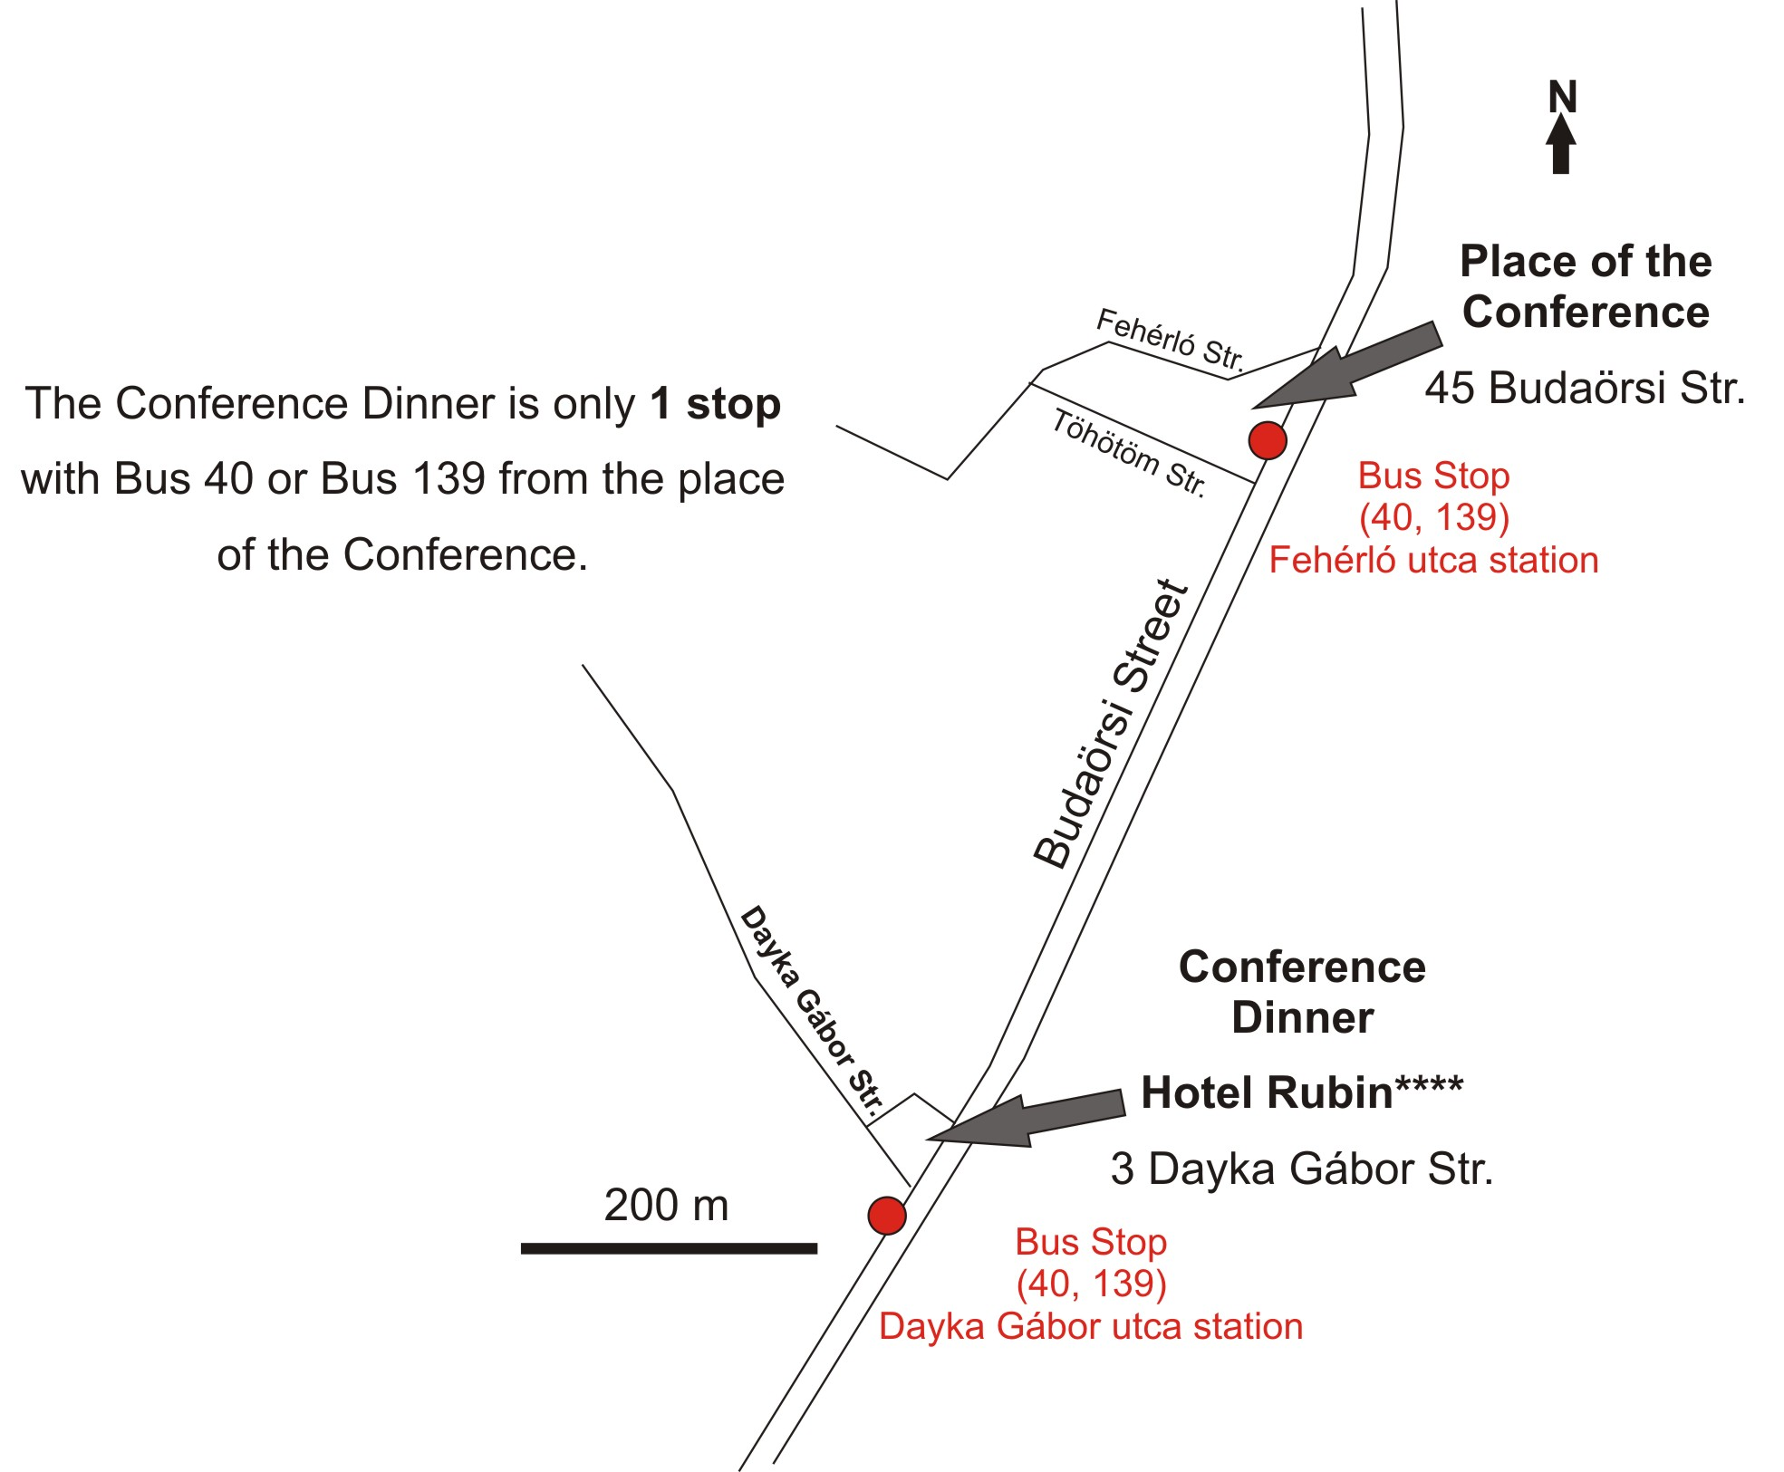

In case of emergency, please call Zsuzsanna Szabó: +36-30/286-0879

The whole building of the venue is a no smoking area. Smoking is allowed outside the building. Please do not overload the elevators.
Budapest is not a dangerous city, but we advise you not to leave your belongings unattended.

